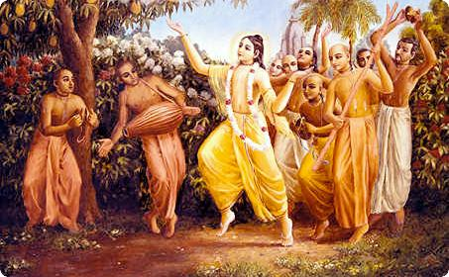
Soldiers of Godhead
May 2011 Special Edition
www.soldiersofgodhead.yolasite.com


Chant Hare Krishna and be happy!
Hare Krishna!
Dandavat Pranams to all readers.
All glories to Srila Prabhupada!
Soldiers of Godhead Magazine has completed one year this May. It has been a great pleasure for me to write this magazine and to preach the message of Lord Krishna and the teachings of His Divine Grace A.C Bhaktivedanta Swami Prabhupada-Founder Acharya of the International Society for Krishna Consciousness. Apart from the magazine, our website has also gained popularity with over 700 hits over a year. Soldiers of Godhead group in social networking website ‘Facebook’ has over a 100 members and growing. All this has been possible only through the blessings of Lord Krishna and Srila Prabhupada. I also wish to thank all the devotees of the Lord who encouraged me to carry on with this preaching. Thank you!
Your humble servant,
Rasabihari Dasa

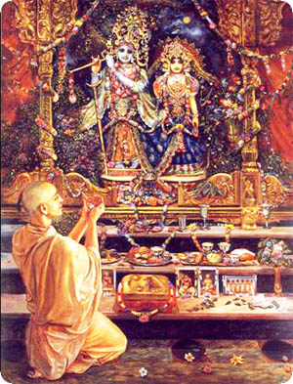This month’s edition is a special edition on devotional service.

Contents
Sr.no Topics Page no.
- Whom to Worship and Why? 7

- The Path of Devotional Service. 11

- Bhakti Yoga The Topmost Yoga. 15

- The Fruit of Devotional Service. 19

- Devotion Is The Solution 24

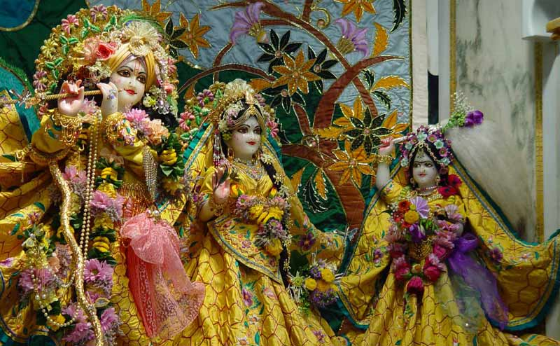
“Always think of me, offer your respects to me and become my devotee. Surely you shall come to me, because you are my dear friend”, says Krishna in the Bhagavad Gita 18.65.

- Whom to Worship and Why?
If the entire Bhagavad Gita is summarized in one statement, then that statement is that Krishna is the Supreme Personality of Godhead. The entire Bhagavad Gita is aimed at directing the conditioned souls to the lotus feet of Lord Sri Krishna. On every page of the Bhagavad Gita one finds this same conclusion that Krishna is the Supreme Personality of Godhead and that there is no one equal or superior to Him, and He is universally worshipable. The Srimad Bhagavatam also gives the same conclusions. All revealed scriptures from the Vedas, Upanishads and Purans are based on the above conclusions.
Krishna says in Bhagavad Gita 15.15 that the ultimate purpose of all Vedic wisdom is to know Him as the Supreme Personality of Godhead. Further it is stated in the Srimad Bhagavatam that Krishna is the Supreme Lord and everyone and everything else are His expansions. Thus, on the authority of the Vedic scriptures, Krishna is accepted by the great sages like Srila Vyasadeva, Madhavacharya, Ramanujacharya, Vishnu Swami, Nimbarka Swami, Lord Chaitanya Mahaprabhu etc as the Supreme Personality of Godhead Himself. Krishna is the Supreme Absolute Truth, the last word in transcendence. We the living entities are His infinitesimal parts and parcels. Living entities are the marginal energy of Krishna. The living entities are equal to Krishna in quality as spirit souls but distinct in quantity. The potencies, energies, abilities, intelligence, memory, oppulences etc of the living entities is limited while that of Lord Krishna are unlimited. The example of the ocean and a droplet of ocean water can be given in this connection. The droplet of ocean water is equal to the entire ocean as far as quality is concerned. It is salty and has the same mineral content as the entire ocean but in far less quantity in comparison to the ocean. This is called inconceivable simultaneous oneness and difference. It is the duty of the part and parcel to serve the whole. Just like the various parts of the body work to satisfy the whole body and do not seek mere individual satisfaction. Thus, the living entities by nature are supposed to serve the Supreme Lord Sri Krishna. But instead of striving to satisfy the Lord, they are seeking their individual satisfaction forgetting their constitutional duties in relation to the Supreme Lord. Just like by watering the root of a plant, all the other parts of the plant are satisfied, similarly when the Supreme Lord Sri Krishna is satisfied, all His parts and parcels are also satisfied. But the living entities owing to their being covered with maya (illusion) believe that simply by serving their own senses and remaining independent of Krishna’s authority can they remain ever peaceful and satisfied. But this is a false notion created due to a poor fund of knowledge. A leaf when separated from a tree becomes dry and decays. Similarly, when the living entities seek their independent enjoyment, they fall into the ocean of material miseries called the material world and undergo repeated birth, death old age and disease. This suffering continues unless and until the living entity reestablishes his forgotten relationship with Krishna and engages in the loving devotional service of the Supreme Lord.
In its struggle for existence, the living entity is engaged in the service of someone or the other throughout the day. A man serves his family by fulfilling its needs and desires, his boss by rendering some form of service for earning a livelihood, his society, community, nation and so on. This service attitude is naturally present in the living entities because as parts and parcels of Krishna, they must engage in rendering service to Him. But since they desire to enjoy independently and deride the authority and even the existence of the Supreme Lord, their service attitude is misdirected and in the course of rendering such mundane service, the living entities go through various forms of sufferings. The only way of crossing over this material ocean of miseries and sufferings is to engage in chanting of the Hare Krishna Maha mantra- Hare Krishna Hare Krishna Krishna Krishna Hare Hare/Hare Rama Hare Rama Rama Rama Hare Hare. By chanting the Holy names of Lord Hari/Krishna one easily overcomes all forms of miseries and sufferings and becomes a fit candidate to go back home, back to Godhead.
Hare Krishna!

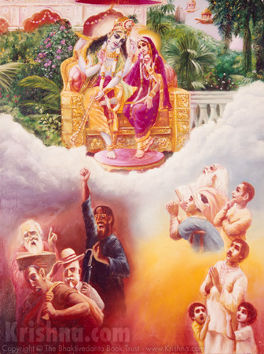
People who are materially distressed or in need of money or inquisitive or in search of the Absolute Truth, surrender to Krishna. Those who are demoniac by nature do not surrender to Krishna.
- The Path of Devotional Service.
Krishna Consciousness is not an arm chair philosophy. It’s a way of life. In the words of Srila Prabhupada, “Our program is sublime. Our philosophy is practical and authorized. Our character the purest. Our program the simplest. But our ultimate goal is the highest.” Krishna Consciousness implies leading a Krishna centered life. When Krishna is the centre and enjoyer of all our activities, our activities become spiritual and are known as devotional service. Devotional Service means to render loving, dedicated and selfless service to the Supreme Lord Sri Krishna with the single aim of satisfying the Lord. Ordinarily people are engaged in rendering service to their family, boss, community, society, country etc. But such services are contaminated since they are not aimed at the satisfaction of Krishna and people render such services for money, sense pleasure, or for boosting their ego. When one directs his service attitude to Krishna, his service becomes spiritual, pure and universally beneficial to all living entities because when Krishna is satisfied, all living entities are automatically satisfied just like by watering the root of a tree, all the branches, leaves, fruits and flowers are nourished.
Krishna is the ocean of mercy. He is known as Achyuta since He doesn’t forget even the most insignificant service rendered to Him by a living entity. Krishna is also easily satisfied when one offers his services to Him according to his capacity with love and devotion. In chapter 9 verse 26 of Bhagavad Gita, Krishna says to Arjuna, that if one offers to Him a leaf (Tulsi), flower, fruit or even a little water with love and devotion, He accepts it. One must engage in Krishna’s service to the best of his ability. If one is not in a good financial position, still one can offer tulsi leaves or some flowers, incense, or ghee lamp to Krishna at least once a day. If one is doing financially well, he can make donations in Krishna’s temples, or construct a temple for Krishna’s worship or engage in any other way in rendering service to the Lord. The point is to serve Krishna according to one’s ability to the fullest.
Devotional Service to Lord Krishna is so nice, simple and eternally beneficial, that if one even my mistake simply chants the names of Krishna, he can achieve the mercy of the Lord, as in the case of Ajamil who engaged in sinful activities all his life and was about to be taken to hell by Yamadutas (the servants of Yamaraj), but because he called out the name of his 5 year old SON Narayan at the hour of death, he was not taken away by the yamadutas and was saved by the Vishnudutas (servants of Lord Vishnu). In the present age of Kali it is not possible for ordinary people to perform sever austerities. Thus, Krishna being merciful on the people of Kali Yuga has established Harinam Sankirtan (congressional chanting of the names and glories of the Supreme Lord Hari) as the Yuga Dharma (prescribed duty for the age). Krishna incarnated as Lord Chaitanya to preach Harinam Sankirtan to the people of Kali Yuga. He propagated the chanting of the Hare Krishna maha mantra- Hare Krishna Hare Krishna Krishna Krishna Hare Hare/Hare Rama Hare Rama Rama Rama Hare Hare. Chanting the holy names of Lord Hari is the only way of achieving perfection in the age of Kali. Along with chanting we can also render other forms of services to the Lord like cooking bhog for the Lord and distributing it as prasadam, distributing books of Srila Prabhupada which educate people about the names and glories of the Lord. One can clean the Lord’s temple, His clothes, paraphernalia etc; One can offer incense, ghee lamp, flowers, fruits, tulsi leaves etc at the lotus feet of the Lord and engage in His loving devotional service. Even a little advancement on the path of Krishna Consciousness can save one from the greatest danger of repeated birth, death, old age and disease. The only qualification required for rendering devotional service is that one must give up meat eating (since non-veg food like eggs, meat, fish etc cannot be offered to Krishna therefore cannot be eaten by devotees), intoxicants like cigarettes, alcohol, drugs, and even tea and coffee, illicit sex life and gambling. By following the above four regulative principles and chanting the Hare Krishna Maha mantra one can easily make rapid advancement in devotional life and thus become a fit candidate to go back home, back to Godhead.
Hare Krishna!
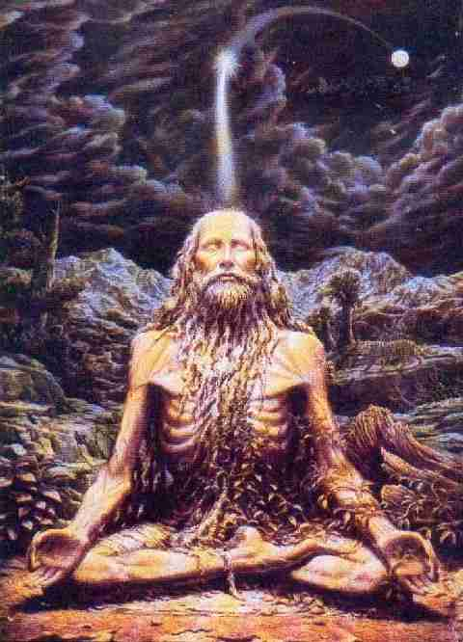
Any form of yoga practice other than Bhakti Yoga cannot free a living entity from the cycle of repeated birth and death no matter how austere they may be.
- Bhakti Yoga the Topmost Yoga.
Avam prasanna manaso
bhagavad bhakti yogaha
bhagavad tatva vijnanam
mukta sangasya jayate
By practicing devotional service, understanding the science of devotion and by associating with the liberated souls one achieves tranquility of mind and perfection. (SB.1.2.18)
The above verse from the Srimad Bhagavatam clearly indicates the significance of devotional service. There are three types of people in the material world. The first type is that of those who are on the sensual platform. They consider sense pleasure to be the ultimate source of happiness and strive hard day and night to achieve sensual pleasure. The second type of people are those who are on the mental platform. They are engaged in mental speculations, forming theories and conducting research works etc. Scholars, scientists, philosophers etc fall into this category. These people consider speculative work to be the ultimate source of pleasure and keep striving to seek more and more of the so called pleasure. The third type of people are the intelligent class of men. They are generally engaged in spiritual practices such various yoga systems like Astanga yoga, Kriya Yoga, Karma Yoga, Dhyana Yoga, Mystic Yoga practice etc and strive to achieve some mystic powers or other supernatural abilities. They are on the platform of intelligence and consider mystic powers to be the highest source of pleasure and work towards achieveing them. So there are people who are on either of the three platforms- body, mind and intelligence. But they have no information about the soul. In the 3rd chapter of Bhagavad Gita, Krishna informs Arjuna, that the mind is above the body and senses, and intelligence is above the mind. But the soul is superior to body, mind and intelligence. The Krishna Consciousness Movement is not just another Yoga System. It is a spiritual movement above body, mind and intelligence since it seeks to establish a direct contact between the soul (living entities) and Krishna- The Supreme Personality of Godhead through the chanting of the Hare Krishna Maha Mantra- Hare Krishna Hare Krishna Krishna Krishna Hare Hare/ Hare Rama Hare Rama Rama Rama Hare Hare. This transcendental vibration is the sound representation of the Supreme Lord (Shabda Brahman). In the age of Kali, people have a reduced life span, reduced memory and intelligence and high levels of anxiety. Owing to this, it is not possible for ordinary people of this age to perform high order austerities like meditation, mystic yoga practice etc. Even if someone manages to perform these austerities, he is simply wasting time, because the Yuga Dharma for this age is to chant the Holy names of Lord Krishna which is very easily accomplished through the chanting of the Hare Krishna Maha mantra. Hence chanting the holy names of Lord Krishna is the topmost yoga practice in the age of Kali. It is confirmed in the Kali Santarna Upanishad:-
Hare Krishna Hare Krishna Krishna Krishna Hare Hare/ Hare Rama Hare Rama Rama Rama Hare Hare
iti sodashakam namnam kali kalmasa nashnam nataha parataropayah sarva vedeshu drishyate
“Chanting the Hare Krishna maha mantra is the only way for destroying the ill effects of the age of kali. No other method is to be found anywhere in the Vedic scriptures.”
Thus, every sane human being shall make the best possible use of his human life by constantly chanting the Hare Krishna Maha Mantra. The tongue that doesn’t chant the names of Lord Krishna is useless. The hands that don’t serve the Lord by offering ghee lamps, incense sticks, flowers, Tulsi leaves etc are useless. The feet that do not go to Krishna’s temples are useless. The mind that doesn’t think about Krishna is useless. The eyes that don’t see the beauty of the deities of Lord Krishna in His temples are useless. The ears that don’t hear about the names and glories of Lord Krishna are useless. Thus, human life which is not Krishna centered is indeed useless.

Hare Krishna!

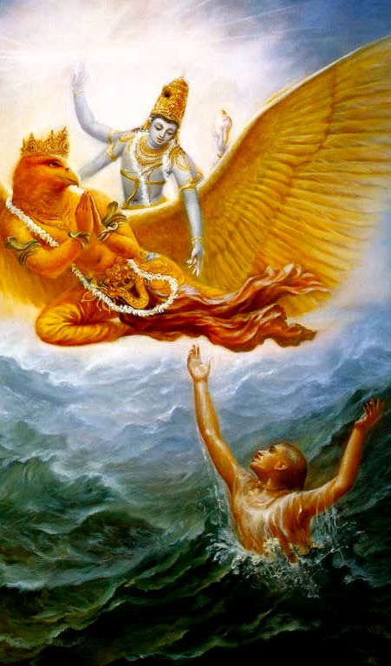
Lord Hari redeems His devotees from the ocean of material miseries of repeated birth, death, old age and disease and takes them to His own abode to lead an eternal life of bliss.
- The Fruit of Devotional Service.
As soon as a living entity re-establishes his relation with Lord Krishna and engages in His loving devotional service, he gradually loses his taste for material sense enjoyment. This is because he relishes the eternal nectar of devotional service and no longer is desirous of the temporary material so-called pleasures. In the initial stages of worship, one is engaged in worshiping the Lord as per the rules and regulations and there is no emotional attachment between the worshiper and the Lord. This is called vidhi bhakti. Gradually, the worshiper advances in devotional service and develops attachment towards the Lord. This devotion with attachment is called raga. When there is further increase in loving attachment between the devotee and the Lord, it is known as anuraga. When anuraga increases and loving attachment between the Lord and the devotee increases, the devotee begins to feel a sense of separation from the Lord and shows symptoms like hair standing on hands and behind the neck, shivering of the body, tears flowing through the eyes due to feeling of separation and a desire to personally meet and serve the Lord. This state of intense love and devotion is called bhav. When a devotee relishes the nectar of bhav, all desires for material sense enjoyment within his heart are drained away by his tears. When bhav further intensifies, the devotee desires to chant and dance in ecstasy and develops pure renunciation from material life and engages in spreading the nectar of devotional service. This intense state of loving devotion for Lord Krishna is called mahabhav. People who prefer to follow the path of point less meditation, yoga practices, ritualistic methods of worship for temporary material gains, cannot even begin to understand the process of pure loving devotional service to the Supreme Lord Sri Krishna. There are others who worship demigods and some who worship bogus god men. But such worship is in the mode of darkness. Only the one who is engaged in rendering pure loving devotional service to the Supreme Lord Sri Krishna, can relish the nectar of devotional service.
Krishna says in Bhagavad Gita 18.65-
man mana bhava mad bhakto
mad yiji mam namaskuru
mam ivaisyati satyam te
pratijane priyo asi me
“Always think of Me, become My devotee and offer your respects unto Me. Surely you shall come to Me because you are My dear friend.”
Here Krishna gives us the clear, simple and sublime path to perfection. He says that we must always think of Him. This is easily achieved when one is always engaged in Krishna’s service in the form of chanting His holy names, cooking food for Him, earning money for Him, worshiping Him, remembering Him, talking about Him, His names, glories, qualities and pastimes, Worshiping Him, Offering respects to Him, Reading about Him, and any other way in which one can engage in His service. Thus, by leading a Krishna Centered Life, we can easily overcome the effects of maya (illusion) and as per Krishna’s promise, at the end of this life one will surely go back home, back to Godhead. In Bhagavad Gita 18.66 Krishna says-
Sarva dharman partitajya
mam ekam sharanam vraja
aham tvam sarve papebheyo
mokshasyami maha sucha
“Surrender all forms of religions and just take shelter of my Lotus feet. I shall free you of all sinful reactions. Do not fear.”
Here Krishna takes personal responsibility of all those who are intelligent enough to become His pure devotees. One must surrender the fruits of all his activities to Krishna. That way one can easily lead a Krishna Centered Life or a life in Krishna Consciousness without taking so called renunciation. Krishna says that one must not be fearful or hesitant. One must engage in Krishna’s worship, service and remembrance and thereby make his life perfect. By gradual advancement in devotional service, one begins to relish the nectar of devotion and ultimately, after death, he is transferred to Krishna’s spiritual kingdom-Goloka Vrindavan where he associates personally with Krishna and all His confidential associates. Indeed pure love, devotion and attachment to the lotus feet of Krishna is the highest perfection one can achieve in the human form of life. Thus, one must endeavor to engage in devotional service to the Supreme Lord Sri Krishna. By gradual advancement one can easily relish the nectar of devotional service and thereby understand the superiority of spiritual pleasure over material so called pleasure. By leading a life in Krishna Consciousness, one can relish the bliss of Krishna’s lotus feet 24/7 and ultimately gain the highest perfection of returning back home, back to Godhead.

Hare Krishna!

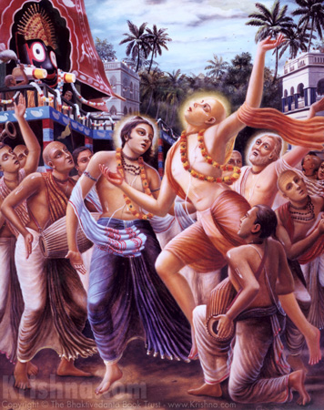
Lord Chaitanya Mahaprabhu inaugurated the Harinam Sankirtan Movement to bring the nectar of the holy name of Krishna into the lives of the conditioned souls of Kali Yuga.

- Devotion Is The Solution
Every living entity in the material world is conditioned by the three modes of material nature-goodness, passion and ignorance. These three material qualities are constantly competing with each other. Therefore sometimes the mode of goodness is dormant defeating the modes of passion and ignorance. Sometimes passion is dormant by defeating the modes of goodness and ignorance and sometimes ignorance is dormant defeating the modes of goodness and passion. In this way, the three modes of material nature condition a living entity and therefore all living entities in the material world are called conditioned souls. Originally, every living entity is pure in consciousness and is engaged in rendering loving devotional service to Lord Krishna. But owing to a desire to enjoy material sense gratification and to remain artificially independent of Krishna, the living entities leave the association of Krishna and fall down into the ocean of material miseries.
In the material world, the living entities have to go through miseries like repeated birth, death, old age and diseases. Every conditioned soul undergoes three fold miseries namely- Adhiyatmik (miseries of mind and body), Adhibhautik (miseries caused by other living entities) and Adhidaivik (miseries caused by demigods and forces of nature). In addition to this, every conditioned soul has four defects- 1. Imperfect senses, 2. Tendency of cheating others, 3. Making mistakes and 4. Being illusioned. Thus, we can conclude from the above that indeed the material world is just like an ocean of miseries. And in order to obtain some temporary relief from these sufferings, people take to abominable activities like meat eating, intoxication, illicit sex and gambling. Some take to the so called yoga practice and meditational techniques. But rather than solving the fundamental issue of conditional life, these temporary and ineffective methods just worsen the problems of living entities. One can understand through practical experience that the above mentioned sources of temporary relief cause short term pleasure but long term complications and problems. Thus, the question arises that what is that technique that can help solve the fundamental problems of living entities like repeated birth, death, old age and diseases? Lord Krishna has dedicated the entire Bhagavad Gita towards answering this question. He clearly says that as long as a living entity wants to remain “independent” and enjoy sense gratification, there is no possibility of achieving liberation from material miseries. But that great soul who surrenders completely to Him (Krishna) is liberated even while he is in the material world and having a material body. But what is the process of surrendering? How can someone in the modern day world surrender to Krishna and engage in His service while being busy with family, career, etc. Krishna knew very well that people in the Kali Yuga would not be able to perform any sever form of austerity because of remaining engaged in material way of life. Thus, to bring relief to His devotees, the Lord came in the form of Lord Chaitanya Mahaprabhu and inaugurated the Harinam Sankirtan Movement by congressionally chanting Hare Krishna Hare Krishna Krishna Krishna Hare Hare/Hare Rama Hare Rama Rama Rama Hare Hare. He clearly declared that it is simply by chanting the Hare Krishna Mahamantra that the conditioned souls can develop love and devotion for Lord Krishna and thereby achieve the highest perfection of human life. By achieving love and devotion for the Lord, a pure devotee loses his taste for material sense enjoyment and relishes the nectar of love of Godhead. The pure devotee factually understands through experience that love of Godhead is superior to material so called pleasures like sex pleasure. The pure devotee becomes aloof from sense enjoyment and engages in serving the senses of Krishna and his only desire is to please Krishna. Krishna also reciprocates this love. And gradually when this loving exchange between the Lord and His devotee intensifies, the devotee is freed from material bondages and goes back home back to Godhead. Thus, keep chanting Hare Krishna, be happy and go back home, back to Godhead!

Hare Krishna!

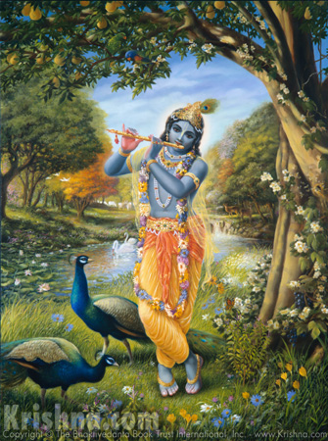

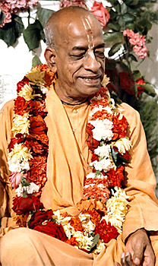
Dedicated at the lotus feet of His Divine Grace A.C Bhaktivedanta Swami Prabhupada-Founder Acharya of the International Society for Krishna Consciousness.
Ever dedicated at the lotus feet of Lord Sri Krishna and Srila Prabhupada.

Written, Edited, Published and Distributed by,
Rasabihari Dasa (Vinay D Chakraborty)

For more information, please visit our website:-
www.soldiersofgodhead.yolasite.com

Send in your views, comments, suggestions or queries if any at vinay.chakraborty@yahoo.com

Chant Hare Krishna and be happy!
Hare Krishna!

